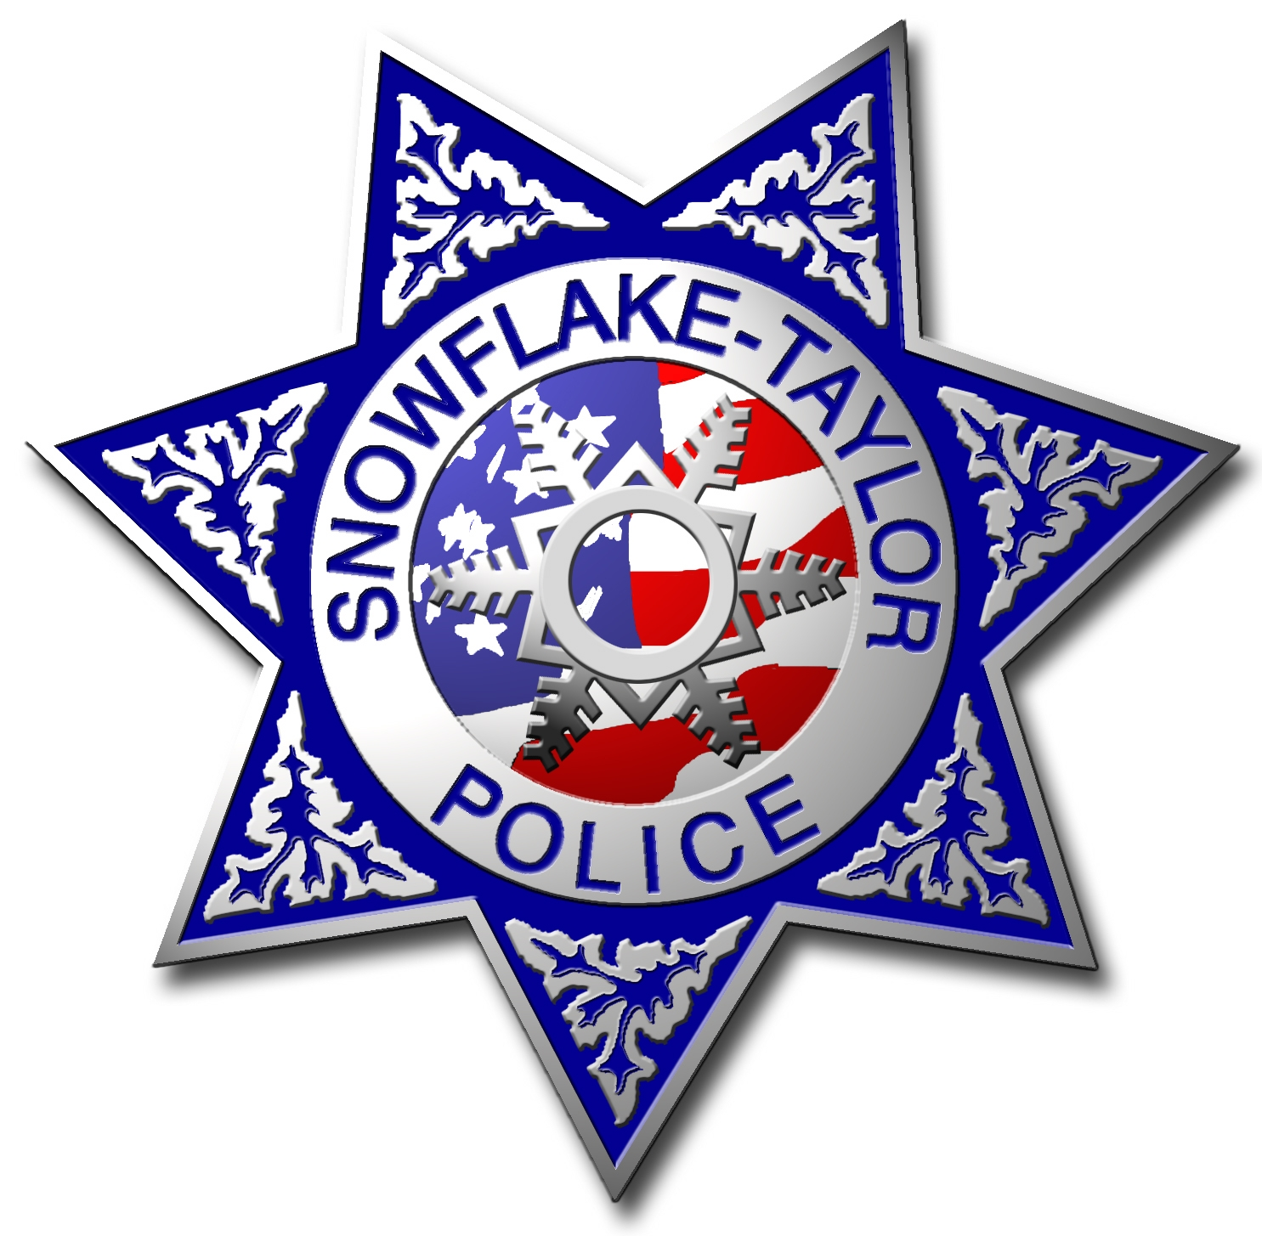
Snowflake-Taylor Police Department
Animal Control Dog License

Note: In order to obtain a license for your dog you must have proof of rabies vaccination.
Licenses expire annually on March 31st.

License Fees: Spayed or Neutered $5.00
Not Spayed or Neutered $7.00
Duplicate License $3.00

Is your dog spayed or neutered? Yes No

PLEASE PRINT CLEARLY

Date:

Owners Name:

Phone Number: Cell Phone:

Physical Address:

Mailing Address:

Dog Name: Breed:

Color: Age: Sex: Female Male

Micro Chip #:___________________________________
For Department Use Only: Do Not Write Below this Line

Tag Number:

Town Rabies Tag Expires: 03/31/20

Sold By: Entered into RIMS By:

